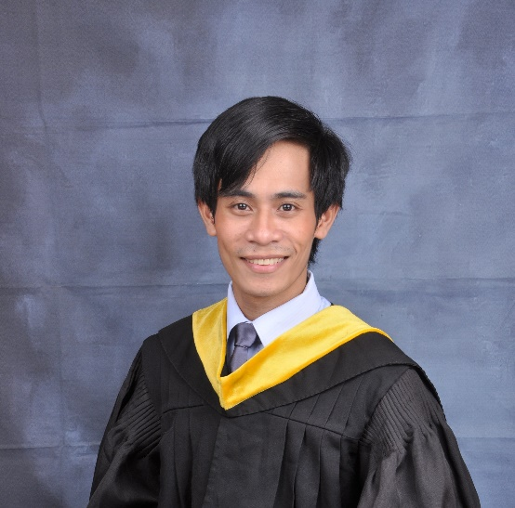

**SHELO M. PAGLINAWAN**

**Address:**

Libertad, Aurora Zamboanga Del Sur

**Phone Number:**

09094991331

**Contact Email:**

[**shelomora60@gmail.com**](mailto:shelomora60@gmail.com)

**CAREER OBJECTIVE**

Looking for a company/organization where I can utilize and practice my skills, experience, and knowledge. And to give my very best to help the company/organization in achieving its mission.

**PERSONAL INFORMATION**

**Course** : Bachelor of Science in Computer Science

**Gender** : Male

**Civil Status** : Single

**Religion** : Roman Catholic

**Nationality**  : Filipino

**Place of Birth**  : Loverslane, Aurora Zamboanga Del Sur

**Age** : 23 years old

**Birthdate** : August 5, 1999

**Height** : 5’2”

**Weight** : 49 kgs.

**Languages** : Cebuano, Filipino, and English

**Mother’s (Maiden Name)** : Emelita A. Mora

**Occupation** : Housekeeper

**Father’s Name** : Benjamin E. Paglinawan

**Occupation** : Carpenter

**----------------------------------------------- SKILLS ---------------------------------------------**

* Computer literate : Microsoft Offices (Word, Excel, Powerpoint)
* Programming : PHP, JavaScript and basic on Java, Python, C#
* Web Development : HTML5, CSS3, React, Node.js, Express.js
* Database : MySQL

**WORK EXPERIENCE**

* OJT

Jose Rizal Memorial State University – Dapitan Campus

Gov. Sta. Cruz, Guading Adasa St, Dapitan City, Zamboanga Del Norte

July 2022 – August 2022 (643 hours)

Work Description:

* Programmer
* Developed a website named Vice President of Research Development and Extension Portal With Plagiarism Detector

**EDUCATIONAL BACKGROUND**

**College** : **Jose Rizal Memorial State University – Dapitan Campus**

Gov. Sta. Cruz, Guading Adasa St, Dapitan City, Zamboanga del Norte

Graduate Batch 2022-2023

Bachelor of Science in Computer Science

**Senior HS** : **Commonwealth National Hight School**

Commonwealth, Aurora Zamboanga Del Sur

Academic Year 2016-2018

Electrical Installation and Maintenance (EIM)

**Junior HS** : **Commonwealth National High School**

Commonwealth, Aurora Zamboanga Del Sur

Academic Year 2012-2016

**Elementary** : **Sergio R. Mascual Elementary School**

Libertad, Aurora Zamboanga Del Sur

Academic Year 2004-2012

**SEMINARS AND TRAINING ATTENDED**

**Online with Certificates**:

**2ND PHILIPPINE SKILLING SUMMIT 2022**, *June 6-8 2022*

**4TH PHILIPPINE SKILLING SUMMIT 2022**,*September 29-30 2022*

**C. E. R. T. FOR CYBERCRIME INCIDENTS**, *October 21, 2022*

**PSITE: “What makes UX/UI Career Exciting”**, *October 14, 2022*